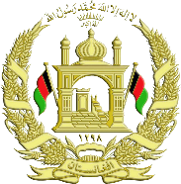
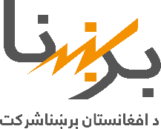
Islamic Republic of Afghanistan
Name of project | Reconstruction of hydro power dam in Greshk district
Location of project | Province: Helmand
Total cost in USD | $ 43 million
Funded by: | Asian Development Bank (ADB)
Entrepreneur | Hunan AIP
Date | The contract end date: 30 June 2017 | The contract start date: 20 October 2012
Project Type | Development Transitional Productive
Total project capacity | Increasing of the productive capacity of dam from 1.5 MW to 4.8 MW
Available mode | Completion and operation Under work Planed
The amount of work (percentages) | 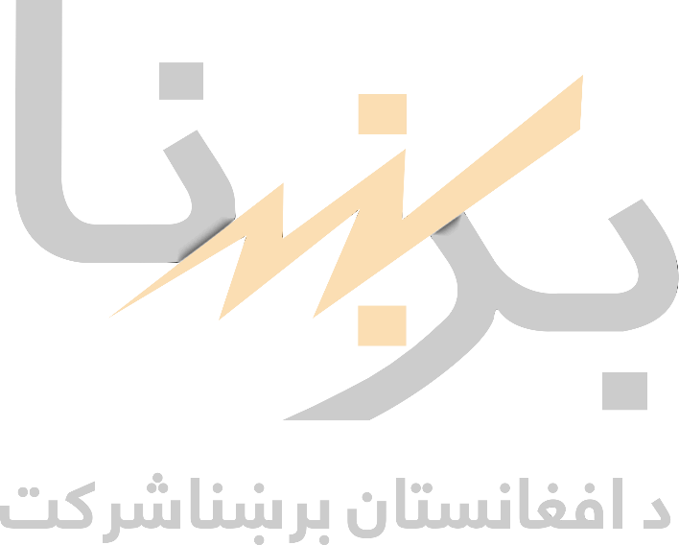  78%
Source of production | Diesel Windy Sunny hydro Charcoal Gaseous imported
Beneficiaries | 5000 families in Greshk city and its neighboring village
Project effects | Improvement of energy supply situation in Greshk city
Brief description | Currently the physical work in the project’s area is stopped. The project’s equipment is transferred to the area, the contract of the consulting company that supervised the project was completed on December 31, 2016 and currently the recruitment of consultants is ongoing
Da Afghanistan Breshna Sherkat
Project information
In addition to the project information and pictures, please email
Tariq.f@dabs.af

