ISLAMIC REPUBLIC OF AFGHANISTAN
Da Afghanistan Breshna Sherkat (DABS

ABBREVIATED RESETTLEMENT ACTION PLAN (A-RAP)
HERAT ELECTRIFICATION PROJECT
(HEP)

PROPOSED KAROKH 31KM, 110KV TRANSMISSION LINE
(A Component of Herat Electrification Project)

Date: January 2019

Table of Contents
ACRONYMS/Abbreviations c
Executive Summary d
1 Introduction 1
1.1. Project Background 1
1.2. Project Development Objective(s) 2
2 Objectives of the Abbreviated Resettlement Action Plan (A-RAP) 2
2.1. Project Affected Families (PAFs) 2
2.2. Verification of ownership of land 3
2.3. Scope & Methodology 6
3. Project Baseline & Socio-Economic Profile of PAFs 7
3.1. Background 7
3.2. Demography 7
3.3. Income 8
4. Public disclosures and Consultations 11
4.1. Stakeholders 11
4.2. Consultation Process 12
5. Institutional framework for implementation of RAP 13
5.1. Project Implementation Unit (PIU) 14
5.2. DABS PIU safeguard team 14
5.3. Local Government(s) 14
5.4. Capacity Building 15
6. RAP implementation mechanism and Schedule 15
6.1. Finalization and validation of PAFs list 15
6.2. Proactive disclosure of A-RAP 16
6.3. Disbursement of compensation 16
6.4. Gender issues 16
7. Abbreviated Resettlement Action Plan & Mitigation measures 17
7.1. Avoiding acquisition to be extent possible 17
7.2. Continued Consultations 18
7.3. Rebuilding and improvement of community infrastructure 18
7.4. Eligibility for compensation 18
7.4.1. General eligibility 18
7.4.2. Land Tenure and Compensation Entitlements 18
7.5. Significant Social Impacts from Project Siting 19
8. Grievance Redress Mechanism 23
8.1. The GRC Structure 24
8.2. Functions of GRC 24
8.3. The DABS- GRM Procedures 25
8.4. GRM Information 25
8.5. Grievance Uptake and Response 25
8.6. Public information sessions and training 28
8.7. World Bank’s Grievance Redress 28
9. Monitoring and Evaluation 29
9.1. Monitoring at PIU Level 29
9.2. Monitoring Indicators 30
Annex A: Key features along the Karokh TL route 30
Annex B :Public Consultation meetings: 41
Annex C: List of PAFs under Karokh TL as per type and quantity of loss 44
Annex D: Compensation options 46
Annex E: PAP individual agreement of land donation 48
Annex F: census survey format 52
Annex G: selected photos 53

ACRONYMS/Abbreviations
A-RAP | Abbreviated Resettlement Action Plan
AP | Affected Person
Arazi | Afghanistan Independent Land Authority
CDC | Community Development Council
COO | Chief Operating Officer
DABS | Da Afghanistan Breshna Sherkat
DPCSP | DABS Planning and Capacity Support Project
ESIA | Environmental and Social Impact Assessment
ESS | Environment and Social Safeguards
ESMP | Environmental and Social Management Plan
GWh | Giga Watt Hour
GRC | Grievance Redress Committee
GRM | Grievance Redress Mechanism
GRS | Grievance Redress System
HQ | Head Quarter
LGUs | local government units
MAIL | Ministry of Agriculture, Irrigation and livestock
M&E | Monitoring and Evaluation
PAP | Project-Affected Person
PAF | Project Affected Families
PIU | Project Implementation Unit
RPF | Resettlement Policy Framework
RAP | Resettlement Action Plan
RoW | Right of Way
WB | World Bank

Executive Summary
Introduction
This document presents the Abbreviated Resettlement Action Plan for the Karokh transmission line project, which will be financed by World Bank. The World Bank’s Involuntary Resettlement Policy (OP 4.12) requires preparation of a resettlement action plan to address issues related to involuntary resettlement and/or the loss of assets or income as a result of the land acquisition. The De Afghanistan Breshna Sherkat (DABS) has developed a Resettlement Policy Framework (RPF) for Herat Electrification Project HEP, which has guided the development of this Resettlement Action Plan of the transmission line project. It gives a description of national legislations and World Bank policy for acquisition of land, provides assessment of impacts, calculation of compensation to project affected persons and the total budget for compensation. This document also provides institutional arrangements for implementation of A- RAP, the implementation mechanism and implementation schedule. Processes designed for grievance redress and monitoring and evaluation.
Scope of the Abbreviated Resettlement Action Plan (A-RAP)
The contents of this A-RAP are designed to meet requirements of the World Bank’s involuntary Resettlement Policy (OP 4.12) and requirements of the government of Afghanistan. This A-RAP is guided by the principles described in the RPF of HEP, the same principles from the RPF will guide preparation of A-RAP for Karokh TL project.
To ensure that this has been complied with, the preparation process has:
- Has identified the project affected persons along the TL route and an assets inventory has been carried out for all the identified project affected persons. The inventory has included affected land, trees and damage to crops and livelihoods
- Public consultations have been held with the PAFs and the community in general, stakeholders and members of the civil society have been consulted.
- Afghanistan’s legal provisions have been compared with the World Bank policies to identify any gaps and necessary recommendations to harmonize the two have been incorporated in the resettlement plan
- This A-RAP enlists economic and other livelihood restoration measures for mitigating effects of other impacts.

Project baseline & Socio-Economic profile of PAFs
Baseline information on Socio-Economic condition of the population living in the corridor of TL and project area of Influence was collected through a study commissioned by DABS-PIU safeguard team during May 2018. The survey was carried out in 9 villages within the corridor of TL covering a sample socioeconomic questionnaires of 189 households. Further to this, a census of all the Project Affected Families (PAFs) was conducted to collect the Socio-Economic information of the PAFs living in the TL corridor. Information was collected on demographic characteristics, employment and income and expenditure patterns of these families. During the first survey 21 PAFs were identified who will be directly affected by the project in terms of loss of land for erection of towers as a permanent expropriation of land and 23 PAFs were identified who will be temporary loss their property or land in case of access road, storage of construction materials, parking of machineries and other construction and electrification activates, among all of the 23 families who will be affected indirectly 21 PAPs are the same who will directly affected. The above mentioned affected families belong to 9 villages which are located along the Karokh TL route.
Legal and Policy Framework for Resettlement
The national legislations with respect to land acquisition and resettlement were reviewed along with World Bank OP 4.12 by an international land specialist in 2007 (McAuslan, 2007) and reflected in the RPF of this project. The review is still applicable since no major changes have taken place with regard to the relevant land laws. There are certain gaps between the Afghan legal framework and the WB operational policies, and the RPF and this RAP provides measures for reconciliation. Afghan laws are silent on PAPs survey and RAP, whereas the WB OP 4.12 requires both in order to ensure a more participatory approach to acquisition. There are also differences on eligibility for compensation between both the legal frameworks. WB policy also requires establishment of a grievance redress mechanism and monitoring and evaluation system.
The A-RAP document provides for a detailed resettlement plan, meeting the objectives of WB policy and provides for a sensitive, transparent and inclusive approach to acquisition and resettlement.
Public Disclosures and Consultations
Starting from the initial consultations carried out at the baseline survey stage during the year 2018 a multilevel consultation approach has been adopted informing the general public about project benefits, disclosure of project information and seeking their cooperation and addressing any concerns raised. Consultations have also been conducted with the potential PAPs for collecting their socio-economic information, informing them about prospective land acquisition. Communities were also consulted in deciding on possibilities of other alternatives in terms of changes in the route of the TL.

Introduction

Project Background
Grid supply dominates for urban households with 89 percent reporting grid access, but it represents the primary supply source for only 11 percent of electrified rural households. Rural areas are dominated by mini grids and stand-alone systems, based primarily on solar and small hydropower plants. Over 5,000 micro hydro plants have been constructed under the National Solidarity Program (NSP) to provide supply to small groups of households in rural communities. Grid access across Afghanistan is also quite heterogeneous across the country’s 34 provinces (or “wilayat”), with some areas having no connections to the grid while others are well served – especially in urban areas. Herat, which has direct links to both Iran and Turkmenistan, enjoys a high level of connections in the capital city. However, areas outside the capital have little or no grid connection, despite the fact that the province as a whole has a reliable and ample source of electricity supply.
Households dominate the customer base, representing almost 93 percent of grid connections, while commercial customers represent just fewer than 7 percent and government agencies less than 1 percent. Total supply from the grid in 2015-16 was 4,773 Gigawatt Hour (GWh), of which 3,767 or 80 percent was imports. Uzbekistan was the main source of external supply (1,284 GWh), followed closely by Turkmenistan (1,184 GWh). Iran supplied 827 GWh and Tajikistan supplied 471 GWh. Domestic generation totaled 1,007 GWh, and was almost exclusively (96 percent) hydro.
Herat Electrification Project (HEP) funded by World Bank, covering several subprojects.
LOT#1, which is construction of four Substations 10 MVA each in Chesht Sharif, Hobai, Pashtoon Zarghon, and Karokh Districts of Herat Province. LOT#2, which is extension of 31km transmission line of 110 kV from existing Salma Dam to Noorul Jahad transmission line up to Karokh Substation. LOT#3 is Supply of Goods and MV/LV equipment for the Electrification of 20/0.4kV network for four mentioned districts of Herat province.
Transmission Line of 31km line of 110 kV from existing Salma Dam to Noorul Jahad transmission line up to Karokh Substation is contracted to Atlas Afroz Sharq. After singing of contract the company requested DABS to start their preliminary route survey for mentioned line before NTP as the contract was not effective, after permission of DABS, they conducted their survey in the site on original route given in contract and 3 other alternative options and subsequently presented their survey report in detail to DABS for review.

Project Development Objective(s)
The Project Development Objective (PDO) is to provide access to electricity to households, institutions, and businesses in selected areas of Herat Province, Afghanistan.

Objectives of the Abbreviated Resettlement Action Plan (A-RAP)
This Abbreviated Resettlement Action Plan is developed in line with the applicable laws and policies of Government of Islamic Republic of Afghanistan and is consistent with the World Bank’s safeguard policy on involuntary resettlement (OP 4.12) and RPF prepared for this project. OP 4.12 requires preparation of an A-RAP for all the projects having potential social impacts, acquisition of land and displacement affecting the lives of persons living there in. This Abbreviated Resettlement Action Plan is prepared for the resettlement approach for the Karokh TL project. This A-RAP aims at:
- Identifying the potential social impacts of the proposed TL project.
- Assessment of the social impacts and suggestive measures for mitigation.
- Identification of Project Affected Persons (PAPs) and Assessment of their entitlements for compensation.
- Developing processes for implementation of the RAP and its monitoring.
- Grievance Redress Mechanism to deal with grievances related to resettlement process.

Project Affected Families (PAFs)
There are total 9 villages falling within the Karokh TL corridor, and total 2,111 families are living in these 9 villages, from the mentioned families, only 21 PAFs were identified who will be directly affected by the project in terms of loss of land for erection of towers as a permanent expropriation of land and 23 PAFs were identified who will be temporary loss their property or land in case of access road, storage of construction materials, parking of machineries and other construction and electrification activates, among all of the 23 families who will be affected indirectly 21 PAPs are the same who will directly affected. Those who well be affected directly as result of towers erection are voluntarily donated their land and the land donation is properly documented and attached as annex E it is to be pointed out that the donated land is less than 10 present of land holding by each PAP which known at the result of census survey, while the temporary affected households who will be affect in case of access road, storage of construction materials, parking of machineries and other construction and electrification activates will be compensated by contractor.

  - Verification of ownership of land
Introduction
The sub-project involves temporary and or partial permanent land acquisition impacts for towers erection and stringing wire in the length of 31 Km area of Robat e Sorkh to Saghari Ha, (total 9 villages) of Karokh district, Herat province.
There are 21 families to be affected by erection of towers as partial permanently acquisition of their land and 23 families to be affected by damage to crops as result of access road, storage of construction materials and temporary acquisition of their land as well as one family to be affected by pulling of 9 sapling of fruit trees (briefly it means, there are 21 + 23+1 families who are going to lose their properties).
It is to be ensured that the Abbreviated RAP is fully in line with the resettlement instrument of HEP RPF, Where impacts on the entire affected families are minor and less than 200 people in term of land acquisition and loss of crops at the result of stringing wire, tower erection, access road and other construction and electrical activities. It is to be noted that single family will not be physically displaced, no physical resettlement will be happen, all the land acquisition is minor than 10 percent of all landholding of affected families.
This Abbreviated RAP is prepared in consultation with PAFs, which presents all details related to the affected families, such as consultation, agreement letters and compensation details which have consideration to PAPs feedback, recommendation and concerns the minute of consultation meeting is attached as annex B. It is essential to note that all 21 owners are title holders and will partially lose their land. However, none of them will require physically relocation. All affected people are agreed in donation of their land for towers erection and provided their written agreements which are included in annex E.
Total numbers of all the affected families (temporary and permanently) are 45 PAFs. However, none of the affected person required physical relocation and so an Abbreviated RAP can be acceptable.
The cost of anticipated temporary affected properties (damage to crop, removal of fruit trees and demolition of land for access road is estimated to be 1,539,000 AFS and should be paid by TL contractor .
Summary of the affected land
1. The project involves a total of 21 affected houses (as permanently loss of land for tower erection), as well as 23 houses will be affected temporary (damage to crops).
2. 21 affected owners (titleholders).
3. Total cost for pulling of 9 small fruit saplings which are not fruiting at present because of its small ages are estimated to be 9000 AFS.
4. Total cost for damage to crops at result of stringing of wire, access road, storage of construction materials are estimated to be1, 530,000 AFS.
4. All affected families agreed in writing to donate their land for erection of towers which is less than 2% of total landholding by each PAFs, it is to be mentioned that the voluntary donation meets the criteria set out in the approved RPF of HEP, however, the PAFs requested compensation for damage to crops and any other affects to their land and agriculture products during project implementation, which will be paid by TL contractor.
5. Details of permanently and temporary land acquisition are given below table 2.1.
6. None of the affected household required physical relocation and livelihood restoration is required for those PAFs who will lose their crops or other assets at the result of stringing of wire, access road and tree cutting.
7. Separate consultations were conducted and summary of consultation with PAPs is included as part of the Abbreviated RAP below (annex B)

List of affected owners
Table 2.1: List of villages and No. of PAFs there in
S/N | Village Name | Number of affected families | Remarks
1 | Rubat e Surkh | - | All 26 towers will be erected in communal land, there are no squatters and encroachers but the mentioned land belong to all residents of the village.
2 | Qala e Pashdan | - | 32 will be erected in governmental land  4 will be erected communal land
3 | Qala e Qasab | 4 | 12 Towers will be erected in communal land  4 Towers will be erected in private land
4 | Majghandak | 3 | 5 Towers will be erected in governmental land  3 Towers will be erected in private land
5 | Qala e Zaman Khan | 6 | 6 Towers will be erected in private land
6 | Qala e Dasht | 7 | All 7 towers will be erected in private land
7 | Qala e Safeed | - | All 13 Towers will be erected in governmental land
8 | Benafshak | - | All 6 towers will be erected in communal land
9 | Mirza Rajab | 13 | All of 13 towers will be erected in private land
10 | Saghari ha/ Merza Rajab | 1 | 1 Towers will be erected in private land  2 Towers will be erected in communal land  4 Towers will be erected in governmental land

Table 2.2: show summary of towers to be erected in private, communal and governmental land.
A. | Land along KTL Route | Quantity
Cultivated land (hectares)
Different land type affecting by towers erection.
1 | Private irrigated land (17 towers) | 0.085 ha
2 | Private rain fed land (17 towers) | 0.085ha
3 | Communal irrigated land (4 towers) | 0.02 ha
4 | Communal rain fed land (15 towers) | 0.075 ha
5 | Communal barren land (30 towers) | 0.15 ha
 | Governmental irrigated land (4 towers) | 0.02 ha
6 | Governmental rain fed land (13 towers) | 0.065 ha
 | Governmental barren (39 towers) | 0.195 ha
 | Sub Total | 0.695 ha

Scope & Methodology
A Resettlement Policy Framework to guide the process of resettlement and compensation issues was been developed by DABS, based on an existing RPF developed for the World Bank funded DPCSPs. This A-RAP is guided by the principles described in the RPF.
This A-RAP covers the villages and PAFs provided in Table 2.1 above and includes the efforts made on consultations and disclosures regarding the resettlement process under the proposed TL project. It covers identification of PAFs and assessment of the extent of impact on their farm land, livelihoods and other socio-economic aspects of lives. It also includes review of the legal policy framework and entitlements. This A-RAP provides for baseline information on the socio-economic condition of the people living in the area and potential impacts of the TL project.
This A-RAP enlists economic and livelihood restoration measures for mitigating effects of other impacts.
The methodology adopted begins from identification of the PAFs, clearly categorized in terms of type of loss, assessment of their socio-economic conditions and calculation of an equitable and compensation for their losses. The activities taken up for preparation of this action plan included the following:
- Discussions with relevant stakeholders under the project
- Consultation with communities
- Survey of PAPs using a questionnaire
- Preparation of the A-RAP

Project Baseline & Socio-Economic Profile of PAFs

Background
Baseline information on socio-economic conditions of the population living in the corridor of Karokh TL project was collected by DABS –PIU safeguard team during May 2018. The survey was carried out in 9 villages which are living along the TL corridor (out of a total of 180 villages in whole district), covering 189 sampled households from total of 2,111 households living along the TL corridor. Analysis of baseline conditions has been provided in the ESIA report and can be used for post project impact assessment for assessing the socio-economic impact of the TL project.
The Abbreviated Resettlement Action Plan deals with land acquisition, resettlement issues and mitigation of adverse impacts on the affected persons and it is imperative to discuss the pre-project conditions of the affected persons in this document. A detailed survey was carried out to assess the status of only the affected families under the project. Structured formats used for collecting data during the survey are provided as annex F.
The process of identification of PAFs was initiated during May and June, 2018 by the DABS-PIU Herat safeguard team and a preliminary survey to collect the socioeconomic information of the project affected families in the villages falling on Karokh TL was conducted. Information was collected on demographic characteristics, livelihood and income & expenditure patterns. Details were also collected on access to education, health and other facilities.
As per this survey, the TL project there are 21 PAFs who are directly affected by the project in terms of loss of land having land titles. Further to this, a 100% census survey were conducted by safeguard team identified 23 families who will get affected by loss crops, fruit trees and other livelihoods.
List of PAFs identified is provided at Annexure C.
  - Demography
All the 21 affected families belong to the following 9 villages/CDCs of karokh district of Herat province mentioned in the table below.
Table 3.1: Number of identified PAFs, by village
S/N | Village | Total affected Household | Total population | Remarks
1 | Qala e Qasab | 2 | 12
2 | Majghandak | 3 | 34
3 | Qala e Zaman Khan | 2 | 22
4 | Qala e Dasht | 7 | 83
5 | Qala e Safeed | - | -
6 | Benafshak | - | -
7 | Mirza Rajab | 6 | 38
8 | Saghari ha | 1 | 9
 | Total | 21 | 199

There are 21 families with total 199 population who are going to lose less than 2 % of their total landholding, which have an average household size of 10 persons. With total of 199 persons of which 47% are male and 53% are female. 32% of the family members are below 10 years of age. Only 3 members (female) in these families are old aged (above 65 years).

Gender | Age Category |  |  | Total
 | 0-9  Years | 10-65  Years | Above 65 Years
Male  Female | 36 | 57 | 3 | 95
 | 30 | 75 | 0 | 104
Total | 65 | 131 | 3 | 199
Table 3.2: Number of identified PAPs, by gender, by age category

  - Income
Data analysis of the income reported by the PAFs reveals an average annual income of AFN 143,400 which approximately is AFN 11,950 per household per month for the affected population.
Table 3.3: Annual Income of PAFs (AFN.), by Type of Activity and percentage of their land to be lost for tower erection as permanent

S/N | PAFs Name | Village | Family members | Percentage of loss per PAF | Monthly income/AFS | Monthly expenditure | Source of income | Remarks
1 | Abdul Salim | Majghandak | 9 | 0.4 | 13000 | 7000 | Farming, Livestock
2 | Haji Karim Bai | Majghandak | 15 | 0.15 | 5000 | 5000 | Farming, Laboring
3 | Haji Aminullah | Majghandak | 10 | 0. 5 | 20000 | 15000 | Farming, Livestock
4 | Arbab Ramazan | Qasab | 9 | 0.06 | 5000 | 5000 | Farming, Livestock
5 | Mohammad Mubin | Saghariha | 9 | 0.25 | 15000 | 15000 | Farming, Livestock
6 | Arbab Mohammad Zaman | Zaman Abad | 16 | 0.08 | 15000 | 12000 | Self-employment and Farming
7 | Mohammad Azam | Qale Dasht | 13 | 0.075 | 10000 | 9000 | Self-employment, Farming and Livestock
8 | Nader | Qale Dasht | 12 | 0.08 | 6000 | 6000 | Farming, livestock
9 | Mohammad Omer | Qale Dasht | 10 | 0.16 | 5000 | 5000 | Laboring and agricultural
10 | Ziauddin | Qale Dasht | 11 | 0.6 | 17000 | 8000 | Farming and laboring
11 | Mohammad Hossain | Qale Dasht | 9 | 0.5 | 5000 | 5000 | Farming and laboring
12 | Sultan Ahmad | Qale Dasht | 15 | 0.25 | 6000 | 6000 | Farming and laboring
13 | Ghulam Sakhi | Qale Dasht | 14 | 0.35 | 5000 | 5000 | Farming and laboring
14 | Bashir Ahmad | Zaman Abad | 6 | 0.5 | 20000 | 10000 | Farming
15 | Mohammad Musa | Mirza Rejab | 13 | 1.5 | 15000 | 12000 | Saffron trading
16 | Haji Karimullah | Mirza Rejab | 7 | 0.12 | 20000 | 15000 | Mayor of Karokh
17 | Haji Aref | Mirza Rejab | 4 | 0.10 | 10000 | 8000 | Self-employment
18 | Haji Nesar Ahmad | Mirza Rejab | 6 | 0.003 | 20000 | 15000 | Shopkeeper and trade
19 | Abdul Salaam | Qasab | 3 | 0.12 | 4000 | 5000 | Government employee
20 | Haji Asef | Mirza Rejab | 4 | 0.0007 | 20000 | 15000 | Farming and live stock
21 | Maruf | Mirza Rejab | 4 | 0.0007 | 18000 | 15000 | Farming and live stock

Public disclosures and Consultations
Stakeholder’s consultation has been a continuous process since the project design was finalized in order to provide information to local communities, population living in the area of influence and other stakeholders. The likely socio-economic impacts, both positive and negative were discussed and efforts were made to obtain their views on the proposed resettlement alternatives. The multipronged approach of consultation has helped the design and planning of resettlement solutions and has also resulted in:
- Active participation of all the stakeholders in design and development of the project preparation processes
- Understanding and incorporating all the major concerns of the affected population
- Addressing the needs and priorities of the affected people in the resettlement plan, ensuring optimum benefits of the project and better acceptability of the resettlement solutions.
The consultation process has been wide and open, gradual and regular thereby resulting in timely, updated and realistic views of all the relevant stakeholders in an open and transparent manner.

Stakeholders

The important stakeholders have been identified and most of these stakeholders have been consulted for the purpose of designing the resettlement processes.
- Project Affected Persons: people who stand to lose as a consequence of the project, all or part of their physical and non-physical assets, including private land, communal land, orchard, resources or important cultural sites, commercial properties, tenancy, income-earning opportunities as well as social and cultural networks and activities. Such impacts may be permanent or temporary. Women members of the affected families were also consulted during the process.
- Da Afghanistan Breshna Sherkat DABS: At the institutional level, the major direct stakeholder is the DABS which is responsible for development of energy in the country. The concerned officers in the DABS are the stakeholders as they are involved in consultations with the PAPs as well as other relevant institutions.
- Office of Governors of Herat: the Office of Governor of Herat Province is also stakeholder as they are involved in the consultations with the villagers as well as in the resettlement process.
- District Governor: are important stakeholders as they will be very closely involved in their entire process of land acquisition and payment of compensation to PAPs.
- Population living in the TL corridor are stakeholders as they will benefit due to electricity in the region that will be created by the project. Women members of the families living in the relevant district were also consulted.
- Local civil society or community based organizations: The local civil society organizations are important stakeholders as they partner with Government in the social and economic development of the project area.

Consultation Process
A multipurpose consultation process has been adopted under the project. Consultation with women are generally challenging in the current Afghan context, as direct consultations need to be gender segregated for cultural reasons. Women of the project area was consulted at different stages of the project – directly through the Baseline study, later through the survey of PAPs, and indirectly through community leaders at different stages of the consultation process.
Figure 4.1: Principles of Consultation Process followed under Karokh TL Project

Disclosure of Information
Open Consultation
Active Participation in Decision Making

The multipurpose consultation approach also informed the general public about project benefits thereby creating an enabling atmosphere; it also resulted in improved participation in the further consultation process at the next stage. The open consultations were facilitated after adequate and transparent disclosure of information, meetings were held in the corridor of TL project area in local mosques and villages along with local leaders and community members.

Institutional framework for implementation of RAP
An extensive description of institutional arrangement for overseeing implementation of environment and social safeguards has been proposed in the ESIA report. Abbreviated RAP implementation will be ensured by the safeguard team, proposed to be formed under the PIU of DABS for this project. Figure below describes the DABS- PIU setup.

Figure 5.1: RAP implementation by PIU under DABS

DABS/PIU
Social Safeguard Specialist
HEP (Herat Electrification Project)

Environmental Specialist

Provincial Social Safeguard Officer (Male)
Provincial Social Officer (Female)
Provincial Environmental Officer

Project Implementation Unit (PIU)
The PIU under DABS already exists with some administrative staff and safeguard team. Complete responsibility of ensuring implementation of the A-RAP will rest with the PIU of Karokh TL Project at HEP -DABS. The PIU, managed by the director will be assisted by the safeguard team with specific task as described further herein, Primary responsibility of PIU will be to ensure smooth land acquisition, resettlement process and disbursement of compensation amounts. The PIU, in addition to the roles prescribed at the time of its formation will now also be entrusted with the following responsibilities:
- Co-ordination with all stakeholders, provincial and district office for implementation of A-RAP
- Facilitate a fair and transparent process of disbursement of compensation amounts to all the eligible affected persons.
- Monitor and supervise roles and functions delegated to safeguard team.
- Capacity building of PIU, Safeguard staff and other stakeholders.
- Overall monitoring of A-RAP implementation and ensuring compliance of all social safeguards in co-ordination with contractors.
- Post project impact assessment
- Effective dissemination of A-RAP document

DABS PIU safeguard team
The role and responsibilities of DABS-PIU safeguard team is management of all environment and social safeguards provided for in the ESMP of Karokh TL project. The PIU safeguard team will also be responsible for implementation of the A-RAP The safeguard team will be responsible for the following:
- Stakeholder consultations for smooth implementation of A-RAP.
- Ensure implementation of gender considerations
- Monitoring the implementation of the abbreviated RAP.
- Public disclosure of all resettlement activities under the project.

Local Government(s)
The cooperation and coordination of the local government units (LGUs) are vital in A-RAP implementation. These are the district government, villages and local community (CDCs). Issues relating from land records and ownership and assets valuation originate from this level and will only be taken to the Council of Ministers if these issues are not resolved locally. The provincial government, in cases of disputes on valuation of land will constitute a land valuation committee to determine the disputes on rates.
In cases of disputes regarding land ownership, land records goes through 3 offices at district level, (1) District administrator, (2) Revenue collector (Mustowfiet) and (3) the district Court. These offices have the jurisdiction on any matters related with land acquisition and verification of land entitlements. Staff of the revenue department (Mustowfiet), with the local municipality will carry out the tasks of identifying the titles and verification of ownership. The Office of district governor is expected to play a coordinating role.

Capacity Building
The PIU will ensure that need based training and capacity building programs are organized for the PIU and safeguard staff. Basic orientation and sensitization of provincial and district officials on resettlement issues will also be provided by the PIU. The A- RAP also provides for training on livelihood restoration and capacity building of PAPs based on their needs.
- RAP implementation mechanism and Schedule
In order to ensure smooth and timely implementation of the project, it is necessary that resettlement processes are completed in time and order, as prescribed in this document. Following activities will have to be initiated and completed in the timeframe suggested below:
Table 6.1: RAP implementation Schedule
S. No. | Activities | Timeframe
1. | Finalization of PAFs list ( direct and indirect PAFs) | 15th August, 2018
2. | Proactive disclosure of A-RAP | February, 2019
3. | Disbursement of compensation( for indirect are temporary affected household) | Before starting of physical work at project area

Finalization and validation of PAFs list
Despite of a multipronged approach adopted for identification of PAFs and collecting their relevant information, a final validation process to review the data collected during the PAF survey will be taken up. As also mentioned above, consultation describing the entitlements, process of claiming compensation and grievance redress procedures, will also be taken up with the PAFs. By this time, the project design team should finalize the changes in design (if any) and freeze the land acquisition requirements.

Proactive disclosure of A-RAP
A proactive approach should be adopted to disseminate the A-RAP and entitlements framework. The awareness generation efforts should ensure flow of information up to the most vulnerable groups like women headed households, physically challenged and absentee PAPs. Focus group discussions and public meetings with community have been already conducted for sufficient information regarding the resettlement processes. Summary of A-RAP, translated in local languages (Dari & Pashto) should be circulated and the complete A-RAP document should be uploaded on local DABS website. This activity shall be completed by end of February 2019.

Disbursement of compensation
Based on the final verification of PAFs, those who well permanently loss their land in the result of towers erection who have donated their land will not be compensated while who affects because of temporary access road, stringing of wire temporary storage of construction materials will be compensated by contractor according to market rate prior to starting physical work at site.

Gender issues
It is appropriate to draw special attention to gender issues within the context of project implementation. Discussions with women in villages visited as part of the Social Safeguards requirements’ review confirmed that they have important, although varying, roles in agriculture which is the main activity which will be encountered during the project implementation. Factors such as absence of male family members from the village, ethnicity and local cultural norms all affect women’s role in agriculture.

Abbreviated Resettlement Action Plan & Mitigation measures
The project implementation is expected to have none significant impact on agriculture land, orchard, and damage to crops on the right of way of the TL project. This chapter discusses the potential impact, efforts to avoid them and mechanisms to ensure a fair and compensation to all the affected persons under this project.
During the consultations conducted, various options in terms of alternatives route selection and impact mitigation measures were explored and the most suitable and feasible options have been adopted in developing this Abbreviated Resettlement Action Plan. All the options discussed and finalized were considered with due diligence to ensure compliance of local laws and principles of World Bank’s resettlement policy. The project design has been finalized and the PAFs have been identified after multiple identification visits and surveys. Wherever feasible, the views and considerations of the community at large and affected persons in particular have been incorporated in developing this Abbreviated Resettlement Action Plan.
Principles of the framework adopted for developing this Abbreviated Resettlement Action Plan are discussed below:

Avoiding acquisition to be extent possible
The OP 4.12 requires avoidance of land acquisition, if possible. Land acquisition and resettlement should not be seen as the easy first option; rather it should be seen as a truly last resort.
In order to meet this objective, an exhaustive social and environmental impact assessment has been undertaken to assess alternatives to avoid acquisition and the financial implications to it. The assessment by the ESIA and followed up consultations with all important stakeholders concluded that after incorporating all possible design alternatives, this TL project has limited amount of acquisition and resultant impacts are unavoidable.
Summary of the assessment and consultations bring out the following justifications, which can be accepted to illustrate that this amount of land acquisition is truly a last resort.
Consultations with population residing in the area of influence and affected persons of the society were conducted in a fair and transparent manner. The emphatic view of all of them was towards the positive impacts and public value of the project as compared to the degree of risk of harms to the affected persons.
There is no direct private benefit or stake involved in construction of the TL project and the extensive consultation process clearly substantiates the need of this project for living standardization of Karokh residents, better security conditions and economic improvements of the local population.
A transparent and participatory process of alternative route options was exercised and the route was selected which have less adverse impacts than other suggested routes.
In line with the basic principle of human rights and in accordance with the spirit of supreme national interest, there was no doubt whatsoever about the need of this project and therefore the unavoidable adverse impacts were required to be accepted but with a true and fair resettlement process to mitigate the effects of such impacts.

Continued Consultations
The A-RAP entails a continued consultation with not only the PAPs but also the other governmental and non-governmental stakeholders. An effective and systematic dissemination of A-RAP has been provided and the issues raised grievance redress mechanism will also be used as inputs for better resettlement planning in the future other such projects in the country.

Rebuilding and improvement of community infrastructure
It is necessary that all community owned facilities affected by the project implementation and any intervention resulting in restricting access to common property resources will be rebuilt, improved and or alternatives provided.

Eligibility for compensation

General eligibility
General eligibility is defined as, “people who stand to lose land, trees, crops, businesses, income and other assets as project affected persons (PAPs)”.
Although it is unlikely that many PAPs will be entitled to compensation or on the grounds that they are losing a substantial amount of land under the project, it is as well to set out the full picture on who PAPs are and what they are entitled to under a project:
- All PAPs losing land with or without title, formal land-use rights or traditional land use rights;
- Owners of buildings, crops, plants, or other objects attached to the land; and
- PAPs losing business, income, and salaries.

Land Tenure and Compensation Entitlements
The largest number of PAPs in the case of Karokh TL Project will be those who will lose a part of their land for TL erection.
Loss of Agricultural land: Compensation at replacement value of land in cash based on current market rates after due consultation with affected people. The meeting participants considered the following inputs and views of the members to conclude on the rates of compensation for temporary land acquisition.
    - Current market rates quoted by local community members
    - Appraising recent sales and transfers of similar type of land in the nearby area within the district.
    - Agriculture productivity rate for land based on market rate.
- Income from crops losses: In case of a land being acquired with standing crops, the owner will be allowed to harvest the crop within the period till such time the TL construction activity is not affected. In case of an urgent need and if the crop is being lost due to the construction related activity, the affected person will be compensated through cash compensation at current market rates for the full harvest of one agricultural season.
- Income losses for workers and employees: Such affected persons will also be entitled for the capacity building & training opportunities on a priority basis. These PAPs shall also be given priority in employment in project related activities.
- Community Structures and Public Utilities: Will be fully replaced or rehabilitated so as to satisfy their pre-project functions.
- Vulnerable Households: Vulnerable people like women household heads, mentally/physically challenged will be given priority in support and rehabilitation for suitable employment opportunities in project related activities.
- Impacts on irrigation canals: Project will ensure that any irrigation channels are diverted and rehabilitated to previous standards.

Significant Social Impacts from Project Siting
Impacts on Land
The total area of the Karokh TL RoW is about 100 hectares (ha) (31km x 30 m). Of this, about 8 ha is cultivated land and the remaining is barren land; see Table 7.1 below.
Table 7.1: Resettlement Impacts
 | Resettlement Impacts | Quantity/ha | Nature of Impact
A. | Land under KTL Towers
1 | Cultivated irrigated land (17 towers ) | 0.085 | Expropriation of land in which towers to be erected. Decreased value and utility of affected land. No construction possible. Limited cultivation possible.
2 | Cultivable rain-fed land (48 towers) | 0.24
3 | Barren land (74 Towers) | 0.37
 | Subtotal (ha) | 0.695
B | Land under Conductors (but not under towers)
1 | Cultivated irrigated land (ha) | 0.27 | Decreased value and utility of affected land. No high-rise construction possible. Cultivation possible, growing of tall trees not possible.
2 | Cultivable rain-fed land (ha) | 4.95
 | Subtotal (ha) | 5.22
C. | Affected area under crops
1 | Total area of agriculture land to be impacted by tower installation and conductor stringing. (ha) | 8.08 | Crop damage
2 | Area under access tracks (ha) | 7.65 | Crop damage
 | Subtotal (ha) | 15.73
D | Affected trees
1 | Privately owned Fruit Trees | 9 sapling | Loss of trees and their produce
E | Project Affected Households
1 | Households losing land | 21HH | Permanently loss land for tower erection
2 | Households losing crops | 23HH | Here 21 HHs repeated in the 23 it means that 21 out of 23 HHs are the same HHs who will loss both land for tower erection and damage to crops
3 | Households losing trees | 1HH
 | subtotal | 45 HH

Mitigation
The resettlement impacts described above will be mitigated in accordance with the national regulations and WB safeguard policies. A summary of the compensation estimates given in the ARAP is presented below.
Table ‎7.2: Resettlement Compensation Estimates
 | Resettlement Impacts | Quantity | Unit Rate  (000 AFN) | Amount  (000 AFN)
A. | Land under Karokh TL Towers
1 | Cultivated irrigated land (ha) | 0.085 | 2,250,000 | 191,250
2 | Cultivable rain-fed land (ha) | 0.24 | 750,000 | 180,000
3 | Barren land (ha) | 0.37 | 550,000 | 203,500
 | Total (ha) | 0.695 |  | 574,750
B | Land under Conductors (but not under towers)
1 | Cultivated irrigated land (ha) | 0.27 | 2,250,000 | 607,500
2 | Cultivable rain-fed land (ha) | 4.95 | 750,000 | 3,712,500
 | Total (ha) | 5.22 |  | 4,320,000
C. | Affected area under crops
1 | Total area of agriculture land to be impacted by tower installation and conductor stringing. (hectares) | 5.915 |  | (covered under B)
2 | Area under access tracks (hectares) | 7.65 | 200,000 | 1,530,000
 | Total | 13.565
D | Affected trees
1 | Privately owned Fruit Trees | 9 | 1000 | 9,000
 | Total affected trees | 9 |  | 9,000
E | Project Affected Households
 | Households losing land | 21
1 | Households losing crops | 23 |  | -
2 | Households losing trees | 1 |  | -

Impacts on Income and Livelihood Sources
The KTL project is likely to damage crops over an area of about 7.65 ha, as listed in Table 7.2. In addition, a total of nine trees will need to be felled. The damages to crops and felling of trees are going to affect the livelihood of 25 households.

Mitigation
For the crop damages, the affected households will be paid cash compensation equivalent to value of crops for one season. Similarly, the owner of fruit tree will be paid cash compensation based on lost production for the entire period needed to re-establish a fruit tree of equal productivity. The affected households will be paid compensation for damaged crops and or felled trees.

Residual Impacts
After payment of the compensation summarized in Table 7.2, the impacts of the project on livelihood of the affected households will be mitigated. Hence the significance of residual impacts will be Negligible, as shown in Table 7.3.

Table 7.3: Total Budget Estimate for A-RAP is AFN 1,539,000 as per details summarized at table below
Component | Amount (In AFN)
Compensation for loss of Land | 574,750 ( which is already donated by PAFs)
Compensation for loss of crops or damage to crops | 1,530,000
Compensation for loss of fruit trees | 9000
Total | 1,539,000

Grievance Redress Mechanism
The Grievance redress mechanism (GRM) is a system of procedures to receive and facilitate resolution of concerns and grievances of project-affected parties arising in connection with a project. The GRM ensures that project-related complaints and concerns received are promptly reviewed and addressed/resolved in an efficient and timely manner, and the complainant informed accordingly. For contractor workforce relevant complaints there should be a separate GRM which will be dealt with grievances of workers on the project site.
The primary objective of this Grievance Redress Mechanism is to ensure that the views and concerns of those affected by project activities are heard and acted upon in a timely, effective and transparent manner. It will also facilitate people who might have objections or concerns regarding the project activities to raise their objections and through conflict resolution so that these can be addressed adequately. The Grievance Redress Mechanism will be transparent, accessible to all, inclusive, participative and unbiased. PAPs will be made fully aware of their rights and the procedures for making a grievance. All grievances need to be recorded in the project level grievance logbook and a central database or excel-sheet along with outcome of grievance redress – and closely monitored and analyzed in terms of category of grievances of speed of resolution.
The main functions of the Grievance Redress Mechanism will be as follows:
- Provide a mechanism to all stakeholders including PAPs to address the concerns arising as a result of project activities, ESMP implementation, eligibility entitlements provided in ARAP and compensation paid,
- Record the grievance of relevant stakeholders include of PAPs, to enable tracking and review categorize and prioritize the grievances,
- Determine and implement the mitigation actions to address the grievances,
- Report to the aggrieved parties about the developments regarding their grievances and the decision of the project authorities
- Monitoring and analysis of grievances, tracking response time
- Inform communities within the project area of influence to utilize GRM services

The GRC Structure
The GRC procedure for WB-DABS supported projects has the following levels:
a- Local level GRC (local level GRC has already established and in place for receiving and handling of the grievance).
b- Project level GRC.
c- DABS level GRC.
Grievance Redress Committees (GRCs) have already been formed across all projects based on World Bank policy which includes members from the relevant project beneficiaries, local governments, Representatives from Project Affected Families (PAF), civil society representative, community representatives.

Functions of GRC
- Ensure that handling of grievances is in accordance with Afghan law and World Bank procedures.
- Ensure that follow-up actions in response to grievances are taken within an agreed time-frame. Maintain record of all registered grievances in a database, along with details on the nature of the issues raised the case history, and actions taken.
- Report on resolved/unresolved grievances a weekly basis to the PIU.
- Coordinate with Government departments, at district, provincial and national level and civil society organizations for resolving the grievances of the local communities.
- Coordinate with community representatives on the efficacy and usefulness of grievance redress procedures and recommend changes if any.
- Assign member(s) to undertake site visits to assess issues raised as and when needed.

The DABS- GRM Procedures
The GRM covers grievances related to both environmental and social concerns. The three elements of the project’s GRM conducted or accessed at three different levels are:
- Efforts made to resolve issues at local level.
- A Grievance Redress Committee at district/project level.
- Appeal mechanism at DABS management level.
DABS and the Project local staffs will be responsible to publicize the complaints procedures to the affected families and will also be responsible for the proper management of the grievance redress. In initial meetings WB-DABS supported projects Environment and Social Safeguards (ESS) staff, together with local government representatives, must inform community representatives about the GRM and explain the various ways of accessing it. ESS staff should explain that a range of mitigation measures to reduce potential negative environmental and social impacts of project activities on communities will be discussed and agreed with community representatives as an integral part of project development.

GRM Information
The Grievance Redress Mechanism (GRM) manual, brochure will be accessible to local community after translation into local languages. A communication campaign will ensure that beneficiaries, CDC and communities, staff and other stakeholders know where and how to submit grievances, with an indication of the process and expected time to reach a resolution.

Grievance Uptake and Response
The DABS/PIU related Grievances should be received from different channels including:
- Complaint Box: will be used where available;
- Hotline and SMS: A mobile number will be introduced DABS has created a separated mobile number (0798856850) for receiving of grievances from beneficiaries. This channel should be applied in all DABS/PIU covered area;
- Grievance Registration Form: This form will be made available in the relevant subproject area to be used by the complainants and can be filled by the help of our staff available in each sub-project;
- Email: Stakeholders having access to internet can send their grievances, comments, and
- Suggestions through emails to Complaints.wbp@dabs.af,
- Personal Visits: Grievances can be recorded by personal visits of community members filling in the standard form at the field level as well as HQ’s related office;
- Project Staff: Grievances can also be filed through project staff
All submitted complaints and grievances will be registered at sub project level and added to a database in the DABS/PIU which will be updated regularly by designated PIU safeguard staff.
DABS/ PIU has established clear policy to make the GRM process transparent to beneficiaries and ensure that it proceeds effectively and efficiently. The project requires the public to submit grievances about the quality of a specific work or services in writing. A complaint handling responsible safeguard staff and relevant project manager reviews each grievance and deals with it according to the following guidelines:
It is one of the most important steps of the DABS/PIU to provide clear feedback of outcome to the complainants. One of the important activities of the GRC will be to provide an acknowledgement to the complainants through email, phone call or personal visits. The complainants must know that their complaints were recorded by the Committee and are investigating the issue. This can only happen when the complainant has identified himself/herself. In case of anonymous complain/grievance, acknowledgement will not be possible. The means through which the complainant has been acknowledged shall also be recorded in the database.
After the grievance/complain is resolved, the Committees must provide a feedback to the complainant. The solutions must also be recorded in the database for reporting to the appropriate authorities.
- Where an individual has a grievance she or he should, first of all, be encouraged to be solved on site between contractor and/or DABS relevant staff and complainant.
- The complaint handling responsible (Safeguard staff) shall record all grievances whether they are referred from GRC members or other recipients.
- The complaint handling responsible safeguard staff shall, within 5-7 working days from receipt of complaint, acknowledge receipt in writing to the complainant indicating that he is considering the issues raised and will discuss them within the local GRC meeting.
- The complaint handling responsible (safeguard staff) shall then consult and hold meeting with the relevant project manager and local GRC members, after a thorough review of the facts, shall make a judgment as to the validity of the complaint.
- The complaint handling responsible safeguard staff shall inform the complainant within 2 weeks of the receipt of the complaint as to the final decision of the investigation.
- If there is no decision after two weeks the complainant can refer the complaint to the project level GRC. The project level GRC chairman or his designated person will chair the committee, which will then examine and address the complaint within 10 days. It is recognized that some complaints may take longer to resolve due to their complexity.
- Project management as well as staff in the DABS/PIU, project level GRC and local GRC will be trained on the development and effective implementation of GRMs.
- If intermediation at local level is unsuccessful, the individual or Affected Person (AP) can take his or her complaint to a formal Grievance Redress Committee (GRC)at District level which will record the grievance and try and resolve issues relating specifically to the implementation of the WB-DABS supported projects. A GRC will consist of the Affected Person (AP), DABS manager of WB-DABS supported projects, DABS Environment and Social Safeguards staff, a representative from local government, a representative from the AP’s community CDC/shura which may be a representative from a women’s CDC, a local NGO representative and the contractor(s).
- The PAP (or his/her representative) may submit his/her complaint in a number of ways e.g. by written letter, phone, SMS messages and email to the GRC or, alternatively, raise his/her voice in a public or individual meeting with project staff. The GRC will meet to try and resolve the matter at local level and make their recommendation to DABS project managers and other project relevant personnel within 7-10 working days from receipt of complaint. If there is no decision after ten days the AP can refer the complaint to the Chief Operating Officer (COO) of DABS in Kabul. DABS/COO will then examine the complaint and address the complaint within 20 days.
Complainants will receive the final feedback within five working days after the issue is resolved. The resolution will be communicated through one of the following channels:
- Message: Either an automatic or manual reply will be sent to the complainants confirming the receipt of their complaints and getting back to them after analyzing it.
- Grievance Feedback Form: An offline either printed or soft Grievance Feedback Form will used to report back to complainant through:
- Email: The complainant, who has sent his /her grievance through email, will receive the final feedback through email.
- Call: The complainant, who has shared his/her grievance through mobile, will also receive feedback through a call by relevant personnel.
- ESS staff should include regular updates and analysis of the GRM with respects to analysis of categories complaints, their resolution and so forth in their quarterly reports and also provides regular feedback to communities and other relevant stakeholders.
- All submitted complaints and grievances will be added to a database/project files which will be updated regularly. Each complaint and grievance should be ranked, analyzed and monitored according to type and degree of priority. The status of grievances submitted and grievance redress will be reported to DABS management through the monthly report.

Public information sessions and training
- DABS- PMU will inform the affected communities/labors/workers of the grievance mechanism and make it easily accessible to them. The mechanism should involve an appropriate level of management (grievance redress committees or GRCs) and address concerns promptly, using an understandable and transparent process that provides feedback to those concerned.
- PMU will conduct public information sessions to inform the affected communities and other stakeholder about the grievance process and report regularly to the public on its implementation, protecting the privacy of individuals.
- Information on ways to make complaints will be readily available to the affected communities and workers- workplace conditions. Leaflets, website links, posters in public places (i.e. Masjids, schools, CDCs center etc.), or complaint boxes at local level are all good ways to make sure that potential complainants can submit their grievances.
- Women and men should have equal access to grievance information.

World Bank’s Grievance Redress
Communities and individuals who believe that they are adversely affected by a World Bank (WB) supported project may submit complaints to existing project-level grievance redress mechanisms or the WB’s Grievance Redress Service (GRS). The GRS ensures that complaints received are promptly reviewed in order to address project-related concerns. Project affected communities and individuals may submit their complaint to the WB’s independent Inspection Panel which determines whether harm occurred, or could occur, as a result of WB non-compliance with its policies and procedures. Complaints may be submitted at any time after concerns have been brought directly to the World Bank's attention, and Bank Management has been given an opportunity to respond. The process to submit complaints to the World Bank’s corporate Grievance Redress Service (GRS) is provided at http://www.worldbank.org/GRS. The process on how to submit complaints to the World Bank Inspection Panel is provided at http://www.inspectionpanel.org.

Monitoring and Evaluation
Effective management of RAP implementation necessitates a robust monitoring and evaluation mechanism. Such a system will not only ensure timely execution of resettlement process but also provide reliable data on performance indicators on the resettlement outcomes. It is imperative for a project of this size to ensure systematic collection of data to monitor and evaluate safeguards performance. The World Bank’s policy also requires development of a comprehensive monitoring and evaluation system to ensure that the RAP is being implemented, in line with its objectives, principles and implementation procedures. M&E system will also generate alarm signals for the management in case of an unpredictable impact.
The monitoring of RAP for this project requires a two pronged approach along with a systematic data management protocol.

Monitoring at PIU Level
Internal monitoring will be carried out routinely by the DABS-PIU through the safeguard team and results will be communicated to World Bank and the DABS through the regular project implementation reports. Indicators for the internal monitoring will be those related to process, immediate outputs and results. This information will be collected directly from the field and reported monthly to the PIU to assess the progress and results of RAP implementation, and to adjust the work program, if necessary. The monthly reports will be consolidated every quarter in standard supervision reports and submitted to the World Bank. Specific monitoring benchmarks will be:
- Information campaign and consultation with PAPs;
- Status of land acquisition and payments on land compensation;
- Compensation for affected or damaged crops and other assets;
- Temporary acquisition of land;
- Relocation of PAPs;
- Payments for loss of income;
- Income restoration activities;
- Grievance received and status of redress;

Monitoring Indicators
A list of suggestive indicators to monitor the progress of RAP implementation is suggested below: These will include primarily the activities and the entitlements due to the displaced people. These include among others:
- Frequency and number of consultations held with various stakeholders; parties engaged in grievance redress and participating in the project such as Community Development Council (CDCs)
- Grievances filed by the PAPs and nature of the grievances including the time it has taken to resolve them
- Procedures in the operations such as asset verification and valuation procedures including effectiveness of compensation delivery system;
- Number of assets compensated and the amounts paid out to the individuals and public facilities restored;
- Number and category of people paid their compensation and rehabilitated including vulnerable groups receiving assistance;

Annex A: Key features along the Karokh TL route
Key Features along Karokh TL Route
 | Village Name | Tower No | Land Type | Land Ownership | GPS Coordinates |  | Elevation
 |  |  |  |  | Longitude | Latitude
1 | Rubate Surkh | 1 | Barren | Communal land | 441509.6310 | 3803631.6420 | 1037.4620
2 | Rubat e Surkh | 2 | Barren | Communal land | 441727.2990 | 3803713.9480 | 1040.1650
3 | Rubat e Surkh | 3 | Barren | Communal land | 442031.0150 | 3803828.7920 | 1043.2640
4 | Rubat e Surkh | 4 | Barren | Communal land | 442260.8480 | 3803915.6990 | 1044.7630
5 | Rubat e Surkh | 5 | Barren | Communal land | 442463.6920 | 3803992.4000 | 1054.5540
6 | Rubat e Surkh | 6 | Barren | Communal land | 442718.4240 | 3804088.7210 | 1057.7980
7 | Rubat e Surkh | 7 | Barren | Communal land | 442882.1960 | 3804150.6490 | 1065.8600
8 | Rubat e Surkh | 8 | Barren | Communal land | 443091.0880 | 3804263.0460 | 1066.5270
9 | Rubat e Surkh | 9 | Barren | Communal land | 443335.0850 | 3804394.3320 | 1076.2010
10 | Rubat e Surkh | 10 | Barren | Communal land | 443476.2810 | 3804470.3050 | 1075.6940
11 | Rubat e Surkh | 11 | Barren | Communal land | 443707.9230 | 3804594.9430 | 1078.1510
12 | Rubat e Surkh | 12 | Barren | Communal land | 443954.1940 | 3804727.4530 | 1081.5960
13 | Rubat e Surkh | 13 | Barren | Communal land | 444220.1360 | 3804870.5470 | 1084.1710
14 | Rubat e Surkh | 14 | Barren | Communal land | 444496.3760 | 3805019.1820 | 1087.8060
15 | Rubat e Surkh | 15 | Barren | Communal land | 444723.9460 | 3805141.6300 | 1092.0000
16 | Rubat e Surkh | 16 | Barren | Communal land | 444943.7810 | 3805259.9150 | 1092.4940
17 | Rubat e Surkh | 17 | Barren | Communal land | 445150.8090 | 3805371.3100 | 1091.0490
18 | Rubat e Surkh | 18 | Barren | Communal land | 445393.3160 | 3805501.7950 | 1093.3900
19 | Rubat e Surkh | 19 | Barren | Communal land | 445562.1090 | 3805592.6160 | 1094.0800
20 | Rubat e Surkh | 20 | Barren | Communal land | 445746.6290 | 3805691.9000 | 1096.5680
21 | Rubat e Surkh | 21 | Barren | Communal land | 445889.2160 | 3805836.4330 | 1097.2700
22 | Rubat e Surkh | 22 | Barren | Communal land | 446054.8110 | 3806004.2890 | 1097.3600
23 | Rubat e Surkh | 23 | Barren | Communal land | 446245.5840 | 3806197.6670 | 1102.6780
24 | Rubat e Surkh | 24 | Barren | Communal land | 446320.2590 | 3806279.6660 | 1104.0400
25 | Rubat e Surkh | 25 | Barren | Communal land | 446498.8630 | 3806475.7880 | 1100.0500
26 | Rubat e Surkh | 26 | Barren | Communal land | 446681.1810 | 3806675.9880 | 1098.9180
27 | Qala e Pashdan | 27 | Hilly | Government | 447066.1910 | 3806621.8970 | 1120.3580
28 | Qala e Pashdan | 28 | Hilly | Government | 447214.6820 | 3806548.4210 | 1133.6500
29 | Qala e Pashdan | 29 | Hilly | Government | 447429.1450 | 3806385.2240 | 1117.1100
30 | Qala e Pashdan | 30 | Hilly | Government | 447569.5310 | 3806278.3960 | 1119.9790
31 | Qala e Pashdan | 31 | Hilly | Government | 447701.2460 | 3806265.4870 | 1119.7170
32 | Qala e Pashdan | 32 | Hilly | Government | 447873.1630 | 3806248.6380 | 1115.8050
33 | Qala e Pashdan | 33 | Hilly | Government | 447981.3450 | 3806263.4470 | 1119.3080
34 | Qala e Pashdan | 34 | Hilly | Government | 448094.3250 | 3806281.5580 | 1117.8750
35 | Qala e Pashdan | 35 | Hilly | Government | 448232.3180 | 3806218.9140 | 1116.6200
36 | Qala e Pashdan | 36 | Grave yard | Communal | 448449.3940 | 3806128.0000 | 1110.3600
37 | Qala e Pashdan | 37 | Grave yard | Communal | 448640.5880 | 3806043.8880 | 1105.7400
38 | Qala e Pashdan | 38 | Grave yard | Communal | 448852.3520 | 3805955.2310 | 1102.0150
39 | Qala e Pashdan | 39 | Grave yard | Communal | 449045.6130 | 3805961.9350 | 1101.0760
40 | Qala e Pashdan | 40 | Hilly | Government | 449193.6580 | 3805970.7730 | 1105.4000
41 | Qala e Pashdan | 41 | Hilly | Government | 449328.1860 | 3805978.8030 | 1097.6330
42 | Qala e Pashdan | 42 | Hilly | Government | 449510.9740 | 3806034.3100 | 1102.8530
43 | Qala e Pashdan | 43 | Hilly | Government | 449664.3500 | 3806080.8860 | 1108.9610
44 | Qala e Pashdan | 44 | Hilly | Government | 449840.8660 | 3806188.1120 | 1113.7230
45 | Qala e Pashdan | 45 | Hilly | Government | 450031.4890 | 3806303.9070 | 1122.0850
46 | Qala e Pashdan | 46 | Hilly | Government | 450049.0160 | 3806504.1920 | 1135.3650
47 | Qala e Pashdan | 47 | Hilly | Government | 450057.0510 | 3806648.5280 | 1139.7090
48 | Qala e Pashdan | 48 | Hilly | Government | 450047.7490 | 3806799.6110 | 1149.0250
49 | Qala e Pashdan | 49 | Hilly | Government | 450025.4700 | 3806947.2140 | 1160.5350
50 | Qala e Pashdan | 50 | Hilly | Government | 449956.1640 | 3807100.7260 | 1165.2950
51 | Qala e Pashdan | 51 | Hilly | Government | 449877.2980 | 3807202.2810 | 1169.1310
52 | Qala e Pashdan | 52 | Hilly | Government | 449824.0570 | 3807351.3830 | 1178.1980
53 | Qala e Pashdan | 53 | Hilly | Government | 449734.2080 | 3807511.9930 | 1187.7130
54 | Qala e Pashdan | 54 | Hilly | Government | 449737.9960 | 3807754.1570 | 1189.9040
55 | Qala e Pashdan | 55 | Hilly | Government | 449758.8530 | 3807923.4860 | 1190.5380
56 | Qala e Pashdan | 56 | Hilly | Government | 449684.6350 | 3808067.2680 | 1168.6470
57 | Qala e Pashdan | 57 | Hilly | Government | 449682.9130 | 3808241.8190 | 1162.0640
58 | Qala e Pashdan | 58 | Hilly | Government | 449646.7150 | 3808345.8080 | 1158.4820
59 | Qala e Pashdan | 59 | Hilly | Government | 449629.8580 | 3808525.5420 | 1152.7510
60 | Qala e Pashdan | 60 | Hilly | Government | 449605.4850 | 3808725.7200 | 1151.0890
61 | Qala e Pashdan | 61 | Hilly | Government | 449607.8170 | 3808867.9810 | 1148.5280
62 | Qala e Pashdan | 62 | Hilly | Government | 449626.5110 | 3808994.2950 | 1151.0830
63 | Qala e Qasab | 63 | Hilly and Rain fed | Communal | 449582.1570 | 3809322.3280 | 1148.1720
64 | Qala e Qasab | 64 | Hilly and Rain fed | Communal | 449623.2780 | 3809449.8520 | 1152.0880
65 | Qala e Qasab | 65 | Hilly and Rain fed | Communal | 449824.5910 | 3809588.8670 | 1161.9410
66 | Qala e Qasab | 66 | Hilly and Rain fed | Communal | 449991.8350 | 3809704.3560 | 1165.6410
67 | Qala e Qasab | 67 | Hilly and Rain fed | Communal | 450209.2770 | 3809969.3280 | 1179.4650
68 | Qala e Qasab | 68 | Hilly and Rain fed | Communal | 450306.0730 | 3810080.4780 | 1184.1600
69 | Qala e Qasab | 69 | Hilly and Rain fed | Communal | 450477.8020 | 3810287.8160 | 1194.7500
70 | Qala e Qasab | 70 | Hilly and Rain fed | Communal | 450575.5230 | 3810418.7020 | 1195.1000
71 | Qala e Qasab | 71 | Hilly and Rain fed | Communal | 450661.4900 | 3810545.7640 | 1189.9240
72 | Qala e Qasab | 72 | Cultivated | Communal | 450743.8380 | 3810667.4770 | 1191.0000
73 | Qala e Qasab | 73 | Cultivated | Communal | 450906.8510 | 3810908.4170 | 1192.6600
74 | Qala e Qasab | 74 | Cultivated | Communal | 451079.5220 | 3811124.9930 | 1194.6540
75 | Qala e Qasab | 75 | Cultivated | Abdul Salaam | 451262.7430 | 3811354.8010 | 1201.4940
76 | Qala e Qasab | 76 | Cultivated | Abdul Salaam | 451448.6270 | 3811587.9480 | 1204.7350
77 | Qala e Qasab | 77 | Hilly | Arbab Ramazan | 451601.8270 | 3811780.1020 | 1204.6210
78 | Qala e Qasab | 78 | Cultivated | Arbab Ramazan | 451775.0970 | 3811997.4300 | 1195.7980
79 | Majghandak | 79 | Hilly | Government | 451900.8170 | 3812155.1160 | 1204.0650
80 | Majghandak | 80 | Hilly | Government | 451963.9130 | 3812234.2550 | 1203.9700
81 | Majghandak | 81 | Hilly | Government | 452150.3570 | 3812492.4390 | 1202.9870
82 | Majghandak | 82 | Hilly | Government | 452247.2980 | 3812626.6800 | 1204.5800
83 | Majghandak | 83 | Cultivated | Communal | 452377.8130 | 3812841.4820 | 1208.0300
84 | Majghandak | 84 | Hilly | Government | 452492.5980 | 3813030.3970 | 1213.4450
85 | Majghandak | 85 | Cultivated | Haji Aminullah | 452636.6300 | 3813254.3250 | 1215.0950
86 | Majghandak | 86 | Cultivated | Haji Aminullah & Abdul Salim & Haji Karim | 452745.3450 | 3813423.3470 | 1217.8000
87 | Majghandak | 87 | Hilly | Haji Aminullah | 452884.7500 | 3813640.0820 | 1222.6440
88 | Qala e Zaman Khan | 88 | Hilly | Arbab Zaman | 452971.3000 | 3813774.6430 | 1222.4290
89 | Qala e Zaman Khan | 89 | Hilly | Arban Zaman | 453110.4710 | 3813991.0140 | 1232.4240
90 | Qala e Zaman Khan | 90 | Rain fed | Arbab Zaman | 453338.3290 | 3814104.6350 | 1238.2530
91 | Qala e Zaman Khan | 91 | Cultivated | Engineer Bashir | 453535.4950 | 3814202.9510 | 1240.8020
92 | Qala e Zaman Khan | 92 | Cultivated | Engineer Bashir | 453708.5860 | 3814289.2620 | 1243.6400
93 | Qala e Zaman Khan | 93 | Cultivated | Engineer Bashir | 453869.6880 | 3814369.5960 | 1244.8960
94 | Qala e Dasht | 94 | Cultivated | Mohammad Umer | 454017.1210 | 3814443.0710 | 1250.3010
95 | Qala e Dasht | 95 | Cultivated | Sultan Ahmad | 454240.4030 | 3814531.0680 | 1252.2120
96 | Qala e Dasht | 96 | Cultivated | Zia U Din | 454467.1740 | 3814620.4410 | 1257.1350
97 | Qala e Dasht | 97 | Cultivated | Nadir | 454690.0280 | 3814708.2690 | 1261.1200
98 | Qala e Dasht | 98 | Cultivated | Ghulam Sakhi | 454922.8080 | 3814800.0100 | 1266.4500
99 | Qala e Dasht | 99 | Cultivated | Nadir/M. Azam | 455150.5500 | 3814889.7640 | 1271.8200
100 | Qala e Dasht | 100 | Cultivated | Mohammed Hussain | 455357.6090 | 3814971.3680 | 1277.0000
101 | Qala e Safeed | 101 | Rain fed | Government | 455535.1110 | 3815041.3230 | 1282.4500
102 | Qala e Safeed | 102 | Rain fed | Government | 455813.9300 | 3815146.7800 | 1293.5300
103 | Qala e Safeed | 103 | Rain fed | Government | 456028.7470 | 3815228.0290 | 1301.2960
104 | Qala e Safeed | 104 | Rain fed | Government | 456274.8690 | 3815321.1180 | 1312.8660
105 | Qala e Safeed | 105 | Rain fed | Government | 456516.3240 | 3815412.4430 | 1310.9920
106 | Qala e Safeed | 106 | Rain fed | Government | 456748.1540 | 3815500.1270 | 1313.2800
107 | Qala e Safeed | 107 | Rain fed | Government | 457011.1640 | 3815599.6040 | 1320.4520
108 | Qala e Safeed | 108 | Rain fed | Government | 457276.4180 | 3815699.9300 | 1331.1600
109 | Qala e Safeed | 109 | Rain fed | Government | 457539.8680 | 3815799.5740 | 1342.8760
110 | Qala e Safeed | 110 | Rain fed | Government | 457782.8120 | 3815891.4610 | 1343.4990
111 | Qala e Safeed | 111 | Rain fed | Government | 457928.2590 | 3815982.7110 | 1347.0420
112 | Qala e Safeed | 112 | Rain fed | Government | 458143.6980 | 3816117.8720 | 1350.8880
113 | Qala e Safeed | 113 | Rain fed | Government | 458391.7830 | 3816273.5140 | 1348.1320
114 | Benafshak | 114 | Rain fed | Communal | 458614.7990 | 3816413.4280 | 1354.3320
115 | Benafshak | 115 | Rain fed | Communal | 458858.2290 | 3816566.1490 | 1358.9000
116 | Benafshak | 116 | Rain fed | Communal | 459053.7780 | 3816688.8310 | 1363.9680
117 | Benafshak | 117 | Rain fed | Communal | 459308.5390 | 3816848.6620 | 1365.4910
118 | Benafshak | 118 | Rain fed | Communal | 459461.5400 | 3816944.6510 | 1367.4300
119 | Benafshak | 119 | Rain fed | Communal | 459631.3390 | 3817037.5020 | 1360.9950
120 | Merza Rajab | 120 | Rain fed | Haji Aref | 459840.6300 | 3817165.1090 | 1365.1850
121 | Merza Rajab | 121 | Rain fed | Haji Aref | 459962.1340 | 3817239.1920 | 1373.9100
122 | Merza Rajab | 122 | Rain fed | Haji Aref | 460192.1920 | 3817379.4610 | 1377.5500
123 | Merza Rajab | 123 | Rain fed | Haji Asef | 460448.7890 | 3817535.9110 | 1383.6620
124 | Merza Rajab | 124 | Rain fed | Haji Asef | 460677.0260 | 3817675.0700 | 1382.7900
125 | Merza Rajab | 125 | Rain fed | Marouf | 460862.7200 | 3817859.6590 | 1389.1290
126 | Merza Rajab | 126 | Rain fed | Marouf | 461061.7470 | 3818057.5020 | 1394.0890
127 | Merza Rajab | 127 | Rain fed | Haji Nisar Karokhi | 461191.8670 | 3818186.8490 | 1398.8210
128 | Merza Rajab | 128 | Rain fed | Haji Nisar Karokhi | 461358.1970 | 3818352.1890 | 1397.3050
129 | Merza Rajab | 129 | Rain fed | Haji Karimullah | 461468.8800 | 3818478.4770 | 1401.8760
130 | Merza Rajab | 130 | Rain fed | Haji Karimullah | 461741.1620 | 3818525.4770 | 1399.4900
131 | Merza Rajab | 131 | Rain fed | Haji Karimullah | 462003.4480 | 3818588.7790 | 1402.0000
132 | Merza Rajab | 132 | Cultivated | Mohammad Musa | 462202.8970 | 3818636.9150 | 1400.4400
133 | Sagharee Ha | 133 | Cultivated | Government | 462413.3690 | 3818768.9070 | 1402.4400
134 | Sagharee Ha | 134 | Cultivated | Government | 462639.3650 | 3818904.9440 | 1404.4040
135 | Sagharee Ha | 135 | Cultivated | Government | 462880.4140 | 3819058.9270 | 1406.0700
136 | Sagharee Ha | 136 | Cultivated | Government | 463127.5670 | 3819216.8110 | 1408.1250
137 | Sagharee Ha | 137 | Rain fed | Communal land | 463365.1560 | 3819381.5340 | 1415.4150
138 | Sagharee Ha | 138 | Rain fed | Communal land | 463581.8520 | 3819531.7730 | 1413.9450
139 | Sagharee Ha | 139 | Rain fed | Mohammad Mubin | 463809.2080 | 3819689.4020 | 1416.4050

List of PAFs identified under Karokh TL Project
S. No. | CDC/Village | PAP Name
1 | Abdul Salim | Majghandak
2 | Haji Karim Bai | Majghandak
3 | Haji Aminullah | Majghandak
4 | Arbab Ramazan | Qasab
5 | Abdul Salaam | Qasab
6 | Mohammad Mubin | Saghariha
7 | Arbab Mohammad Zaman | Zaman Abad
8 | Mohammad Azam | Qale Dasht
9 | Nader | Qale Dasht
10 | Mohammad Omer | Qale Dasht
11 | Ziauddin | Qale Dasht
12 | Mohammad Hossain | Qale Dasht
13 | Sultan Ahmad | Qale Dasht
14 | Ghulam Sakhi | Qale Dasht
15 | Bashir Ahmad | Zaman Abad
16 | Mohammad Musa | Mirza Rejab
17 | Haji Karimullah | Mirza Rejab
18 | Haji Aref | Mirza Rejab
19 | Haji Nesar Ahmad | Mirza Rejab
20 | Haji Asef | Mirza Rejab
21 | Marouf | Mirza Rejab

Annex B :Public Consultation meetings:
Consultation meetings with the community and PAPs along the Karokh TL corridor
Name of the project location Karokh Transmission Line Project
Name of the villages Covered
during Consultation Meetings: Robat e Sorkh ,Pashtan ,Qasab ,Zamankhan ,Qala e Safied , Machghandak , Banafshak, and Saghari ha villages
Name of the districts Karokh
Name of the provinces Herat
Consultation meetings 12 May 2018 – 20 May 2018 (9 village level meetings)
(Local people and PAPs)

Issues Discussed | People Views and Suggestion
General perception about the project and the awareness about the proposed  (Karokh 31 KM, 110 KV Transmission Line) | They have favorable opinion about the project. People were partially aware about the project but they became more aware during the consultations and meetings. Local people expressed their readiness for (loss of asset, removal of orchard and land acquisition) and cooperation about project implementation and would like the project to start as soon as possible.
Support of local people for the proposed project | All the participants promised that they will extend full support to the project. They assured their support and security and also promised locally available skilled and unskilled labor and local raw materials like stone and sand for construction at reasonable cost.
Identification of Environmental & Social sensitive location | During the transect walk with the community, No environmental/socially sensitive location along the TL route was identified.

Issues Discussed | People Views and Suggestion
Choices during the project design, construction and operation stages | The community suggested that their viewed should be considered during the implementation of TL project. No major change was suggested by them at the select route of TL. They also suggested that there should be continuous consultations with the local people,  Unskilled labor should to be hired from the surrounding villages.
Land acquisition | Community and PAPs were informed about the needed land for towers erection as permanent expropriation and land acquisition for access road and construction materials storage as a temporary acquisition, the meeting participants and PAPs donated their land for tower erection as a permanent and provided their written agreement letters both individual and village wise which are attached as annex E  The meeting participants and PAPs suggested for compensation in the case of damage to their crops at the result of access road, construction materials storage and other construction and electrification activities. Also individual consultations were conducted with each individual PAPs.
Grievance Redress Committee (GRC) | A Grievance Redress Committee was established having representation of DABS- PIU, District authorities and representatives of community and PAFs.
Tree removal | Some minor fruit trees (9 sapling) will have to be removed and the community demanded compensation and replantation of new trees.
General socio-economic impact | The main economic activity is agriculture and livestock. Farmers are engaged in cultivation of wheat, barley, vegetable and wheat are major crops in the area. Some people are engaged in small business and employment opportunities in Karokh district but more people migrate for daily wage to other place like Herat city and foreign country like Iran. The proposed TL is expected to benefit the economic activities directly or indirectly.
Transparency during the project implementation | The ESIA consulting team promised transparency all through the project
Jobs availability to the locals | Jobs will be availed to the locals in time of operation phase.
Views of women | All women were happy and welcomed the Project.

Annex C: List of PAFs under Karokh TL as per type and quantity of loss
S. No. | PAP Name | Village Name | Cultivable Land/sqm |  |  | Remarks
 |  |  | Owned | Loss | %
1 | Abdul Salim | Majghandak | 6,000 | 25 | 0.4
2 | Haji Karim Bai | Majghandak | 16,000 | 25 | 0.15
3 | Haji Aminullah | Majghandak | 20,000 | 100 | 0. 5
4 | Arbab Ramazan | Qasab | 144,000 | 100 | 0.06
5 | Abdul Salaam | Qasab | 20,000 | 100 | 0.25
6 | Mohammad Mubin | Saghariha | 60,000 | 50 | 0.08
7 | Arbab Mohammad Zaman | Zaman Abad | 200,000 | 150 | 0.075
8 | Mohammad Azam | Qale Dasht | 60,000 | 50 | 0.08
9 | Nader | Qale Dasht | 30,000 | 50 | 0.16
10 | Mohammad Omer | Qale Dasht | 8,000 | 50 | 0.6
11 | Ziauddin | Qale Dasht | 10,000 | 50 | 0.5
12 | Mohammad Hossain | Qale Dasht | 20,000 | 50 | 0.25
13 | Sultan Ahmad | Qale Dasht | 14,000 | 50 | 0.35
14 | Ghulam Sakhi | Qale Dasht | 10,000 | 50 | 0.5
15 | Bashir Ahmad | Zaman Abad | 10,000 | 150 | 1.5
16 | Mohammad Musa | Mirza Rejab | 40,000 | 50 | 0.12
17 | Haji Karimullah | Mirza Rejab | 140,000 | 150 | 0.10
18 | Haji Aref | Mirza Rejab | 4,000,000 | 150 | 0.003
19 | Haji Nesar Ahmad | Mirza Rejab | 80,000 | 100 | 0.12
20 | Haji Asef | Mirza Rejab | 14,000,000 | 100 | 0.0007
21 | Marouf | Mirza Rejab | 14,000,000 | 100 | 0.0007
a

Annex D: Compensation options
S.N. | Owner Name | District | Village Name | Population per family | Type of land | Land compensate  Yes /No | Remark
1 | Abdul Salim | Karokh | Majghandak | 9 | Agriculture land | No | All of PAPs voluntarily donated land for towers erection
2 | Haji Karim Bai |  | Majghandak | 15 | Agriculture land | No
3 | Haji Aminullah |  | Majghandak | 10 | Agriculture land | No
4 | Arbab Ramazan |  | Qasab | 9 | Agriculture land | No
5 | Abdul Salaam |  | Qasab | 9 | Agriculture land | No
6 | Mohammad Mubin |  | Saghariha | 9 | Agriculture land | No
7 | Mohammad Zaman |  | Zaman Abad | 16 | Agriculture land | No
8 | Mohammad Azam |  | Qale Dasht | 13 | Agriculture land | No
9 | Nader |  | Qale Dasht | 12 | Agriculture land | No
10 | Mohd Omer |  | Qale Dasht | 10 | Agriculture land | No
11 | Ziauddin |  | Qale Dasht | 11 | Agriculture land | No
12 | Mohd Hossain |  | Qale Dasht | 9 | Agriculture land | No
13 | Sultan Ahmad |  | Qale Dasht | 15 | Agriculture land | No
14 | Ghulam Sakhi |  | Qale Dasht | 14 | Agriculture land | No
15 | Bashir Ahmad |  | Zaman Abad | 6 | Agriculture land | No
16 | Mohammad Musa |  | Mirza Rejab | 13 | Agriculture land | No
17 | Haji Karimullah |  | Mirza Rejab | 7 | Agriculture land | No
18 | Haji Aref |  | Mirza Rejab | 4 | Agriculture land | No
19 | Haji Nesar Ahmad |  | Mirza Rejab | 6 | Agriculture land | No
20 | Haji Asef |  | Mirza Rejab | 4 | Agriculture land | No
21 | Marouf |  | Mirza Rejab | 4 | Agriculture land | No

Annex E: PAP individual agreement of land donation
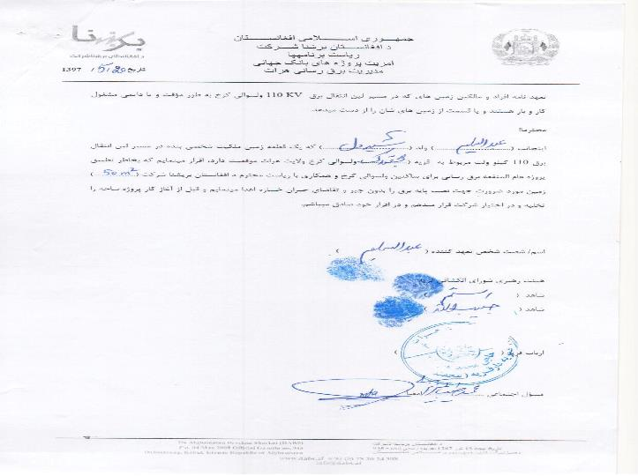

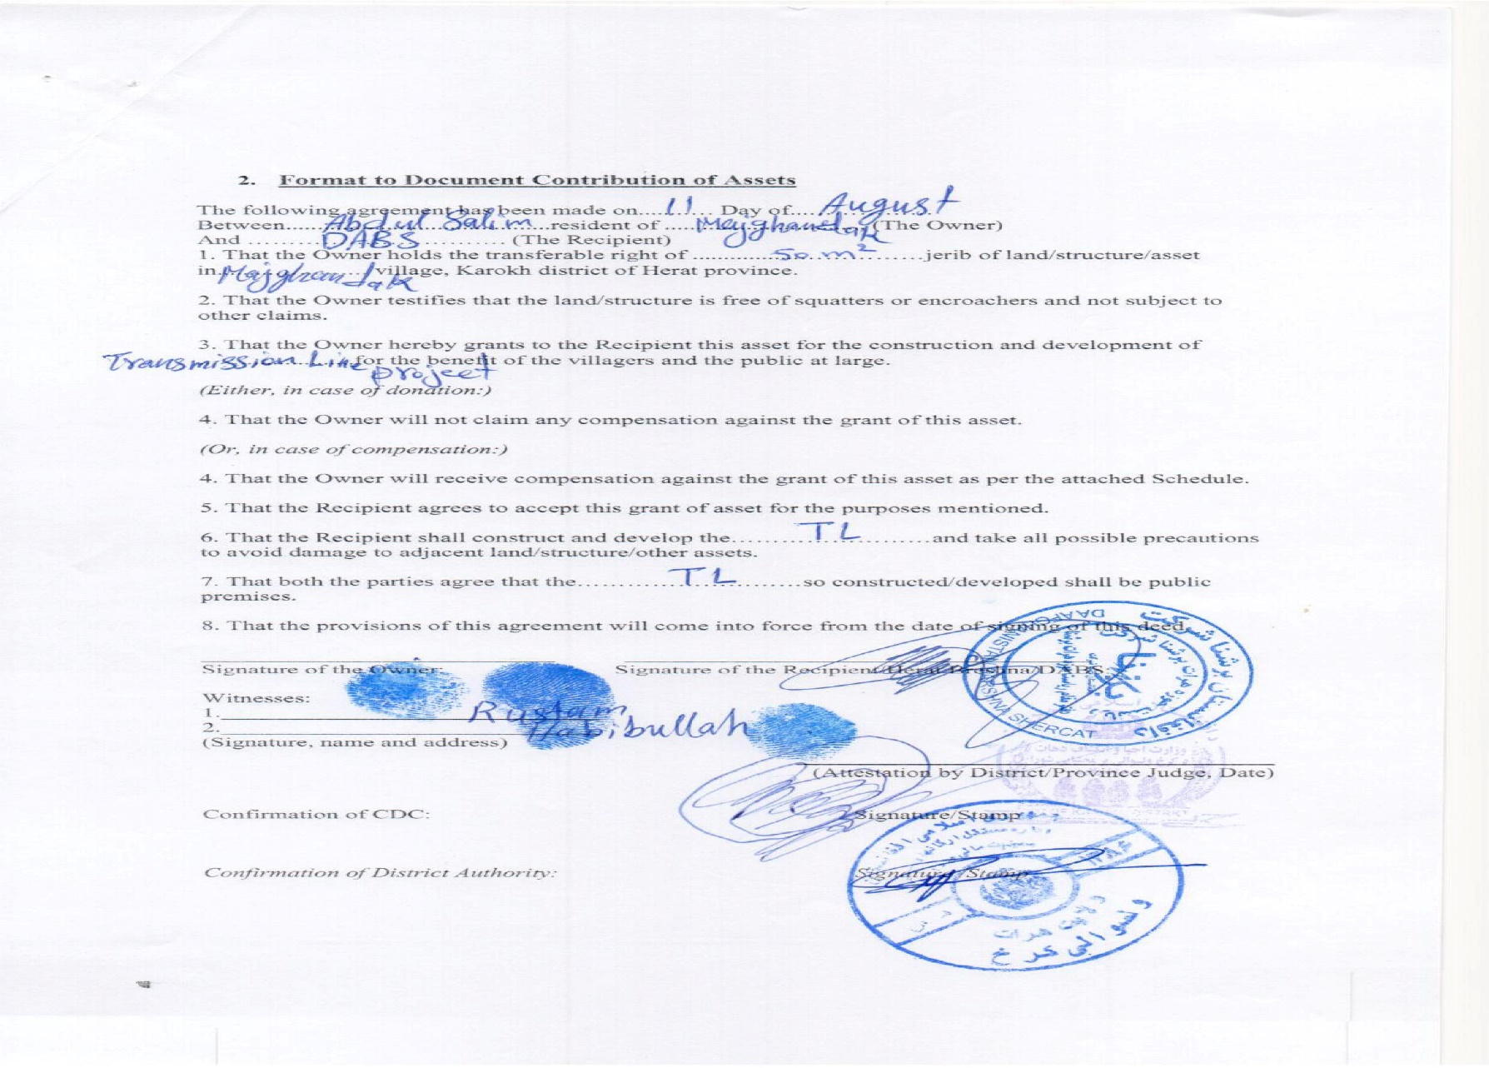

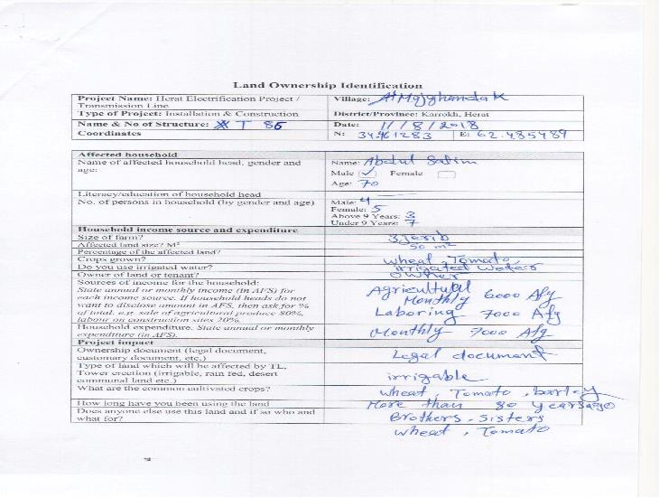

Village based/level community agreement letter

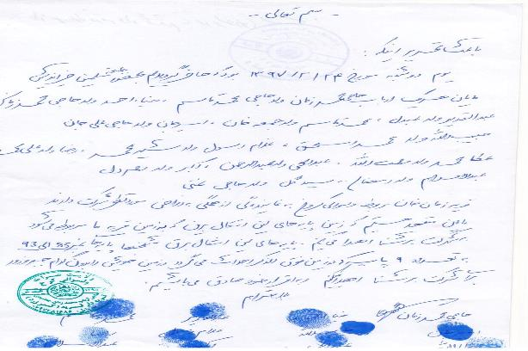

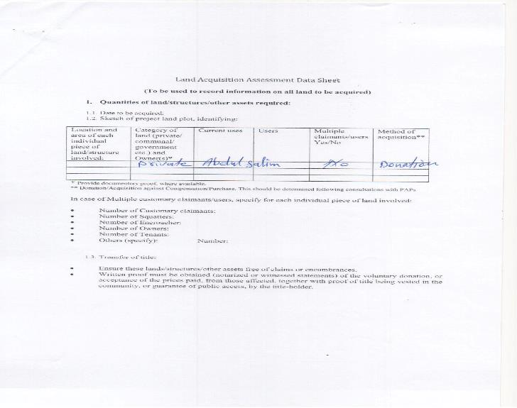
Annex F: census survey format

Annex G: selected photos
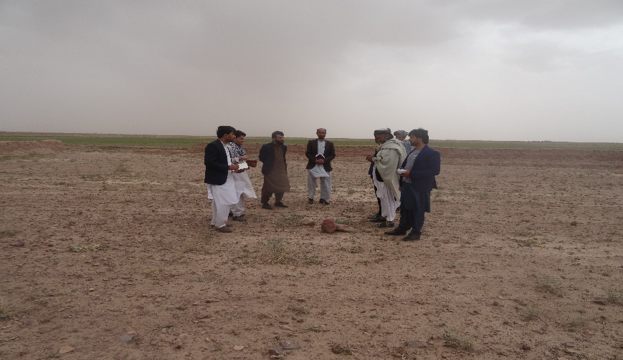 | 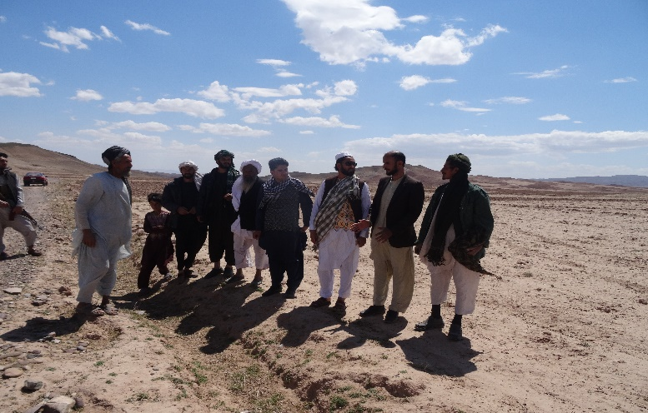
Open discussion/consultation with PAPs, regarding the selected place for tower erection. | Site observation with affected people
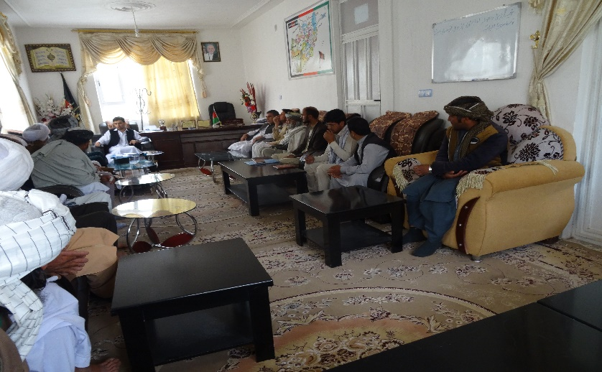 | 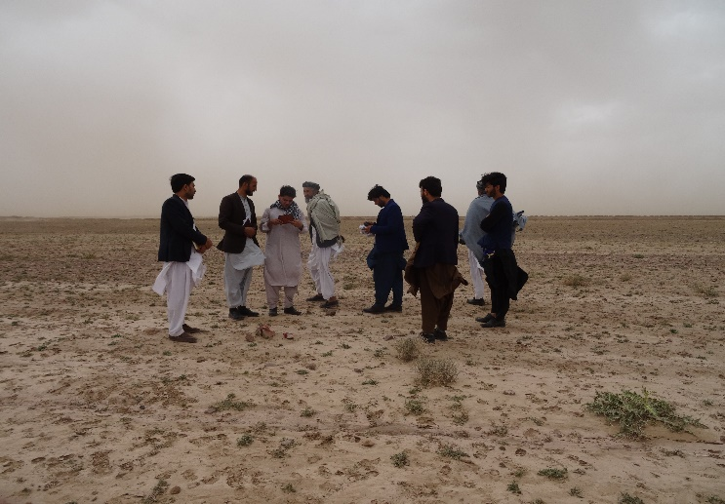
Consultation meeting with GRC members and district governor regarding land donation and individual agreement of affected families | Site observation and filling of census from affected person
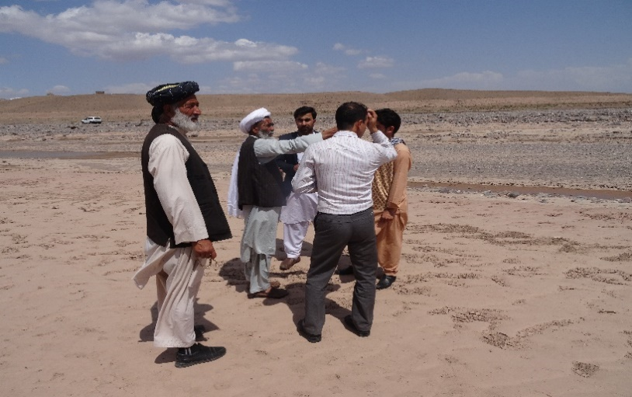 | 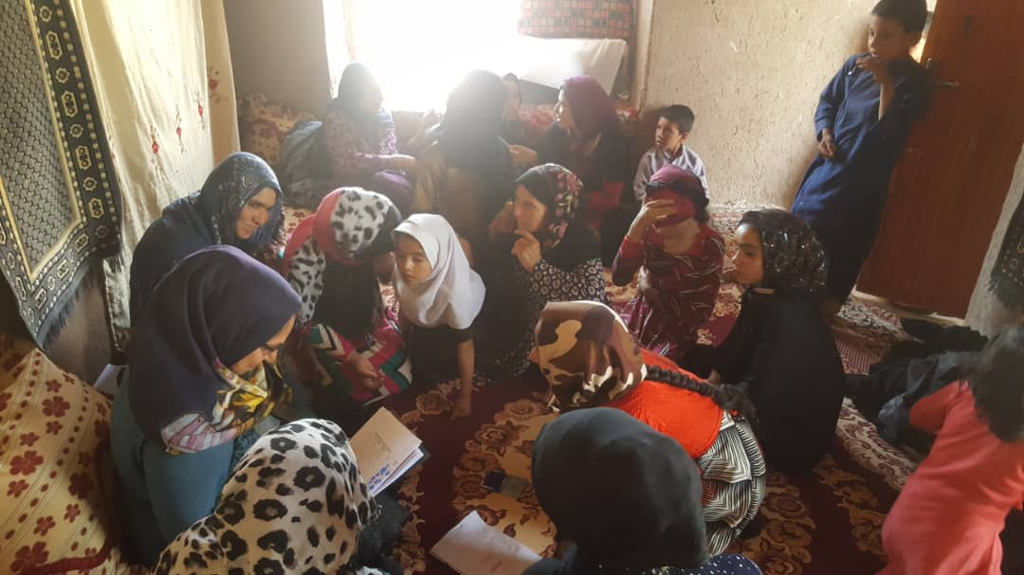
Discussion about TL route with affected people | Women consultation meeting
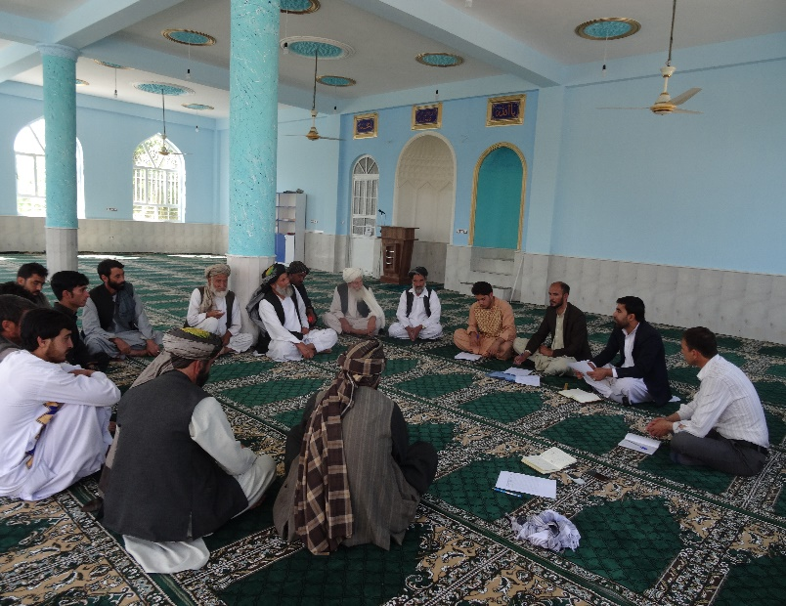 | 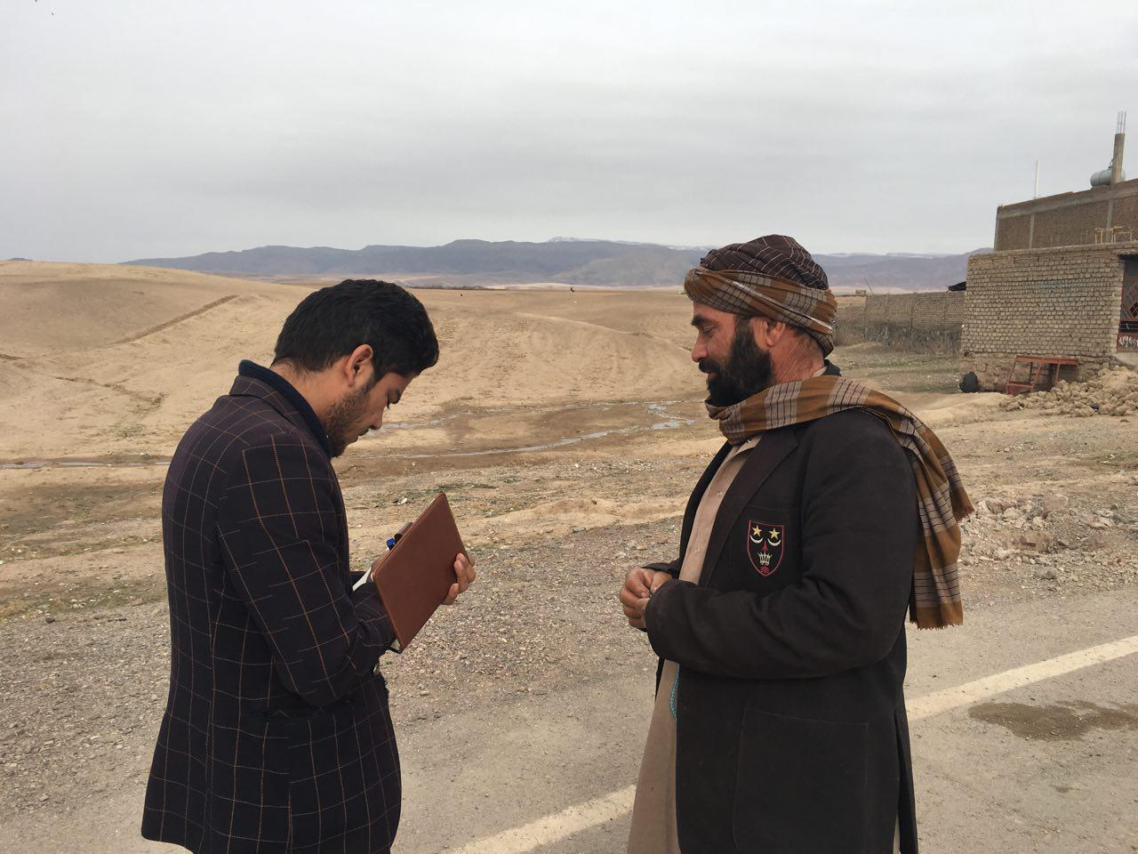
Male consultation meeting | During filling of census form

